BlackBerry mOcean SDK

Developer Guide

Version 2.10

Table of Contents

Table of Contents 2

What’s new in 2.10 3

How to move from previous version to 2.10 4

System Requirements 4

Feature list 4

Installing the Ad SDK 5

Add the Latest version of SDK library project to your app 5

Use case MASTAdView 7

Simple ad integration 7

Interstitial ad integration 8

Customize MASTAdView 10

Customize view appearance. 10

Customize Interstitial ad 11

Customize view appearance. 11

Customize Ad Updates 11

# What’s new in 2.10

* The prefix ‘MAST’ was added for public classes
* The class AdserverInterstitial was deprecated
* The property showCloseButtonTime was added to MASTAdView
* The property autoCloseInterstitialTime was added to MASTAdView
* The property autoCollapse was added to MASTAdView
* The property showPreviousAdOnError was added to MASTAdView
* Ignore content, if server returned response code != 200, but follow up 30x redirection
* The sample applications were updated

# How to move from previous version to 2.10

1. You should change all ads of the class from “Adserver” into “MASTAdview”
2. You may use “MASTAdview” instead of “AdserverInterstitial” in the current version, please pay attention that in the next versions the current class will be removed, so we recommend to use “MASTAdview”.
3. For the usage of the interstitial banner through MASTAdview, it’s necessary to setup showCloseButtonTime or autoCloseInterstitialTime in the meaning of more than -1.

# System Requirements

* Microsoft Windows XP or later.
* IDE, supports BlackBerry environment:

Eclipse (http://us.blackberry.com/developers/javaappdev/javaplugin.jsp)

Netbeans (http://netbeans.org/downloads/index.html) with Blackberry plugin (http://plugins.netbeans.org/PluginPortal/faces/PluginDetailPage.jsp?pluginid=11194 )

BlackBerry JDE (http://us.blackberry.com/developers/javaappdev/javadevenv.jsp )

# Feature list

* **HTML/ JS ads** (java script is limited by BrowserField2 capabilities)

SDK supports displaying web ads using BrowserField2 component.

* **Location auto detect**

SDK could automatically detect user location

* **User-Agent auto detect**

SDK automatically detects device User-Agent

* **Ad visibility tracking**

SDK automatically disables ads updates on visibility ad hiding.

* **Logging**

SDK supports logging.

# Installing the Ad SDK

## Add the Latest version of SDK library project to your app

1. Add the MASTAdview.jar file into library folder.

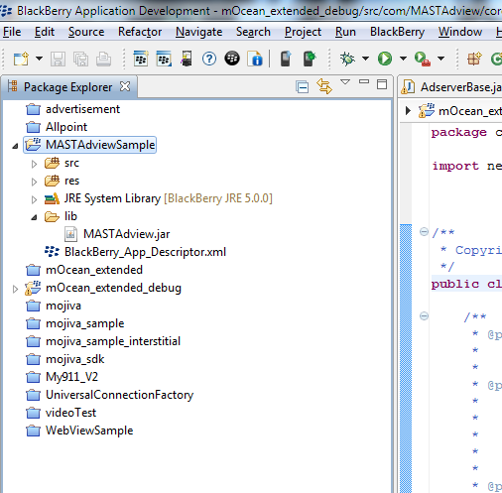

## 

1. Add mOcean SDK jar into project build path

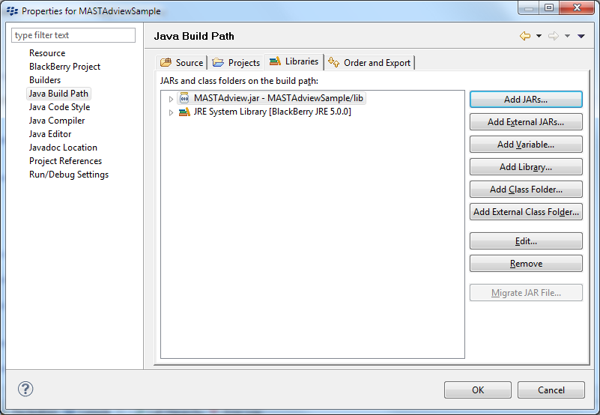

1. Open “Order and Export” tab and select MASTAdview.jar

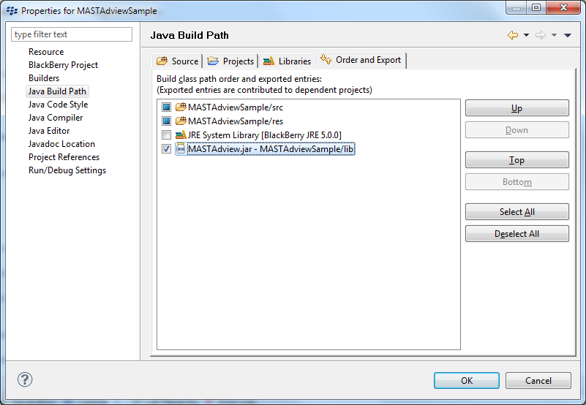

# Use case MASTAdView

1. A simple banner that is used for the embedding of the existing form and occupies a small area in it.
2. Interstitial is used for the full screen banner display. It’s displayed only once and after closing it becomes inactive.

# Simple ad integration

To add MASTAdView into your application just import com.MASTAdview.core.MASTAdview class

import com.MASTAdview.core.MASTAdview;

put initialize code

MASTAdview field = **new** MASTAdview(19829, 88269);

field.setSize(360, 50);

field.setUpdateTime(20);

field.setLoggerId("AdLogger1");

and add field to screen

add(field);

For more code samples examine Samples application

If there are several banners of different sizes in the same Zone, this can be useful for the targeting of the different devices, but it’s necessary to determine, the proper size of the banner for each device. For the determination of the size, please use the following parameters minSize and maxSize.

field.setMinSizeX(320);

field.setMinSizeY(50);

To determine correct banner for portrait and landscape redefine sub-layout for current screen:

public void sublayout(int width, int height)

{

if(Display.getOrientation()== Display.ORIENTATION_LANDSCAPE)

{

field.setSite(8061);

field.setZone(16741);

int displayWidth = Display.getWidth();

field.setSize(displayWidth, 50);

field.update();

}

else if(Display.getOrientation()== Display.ORIENTATION_PORTRAIT)

{

field.setSite(8061);

field.setZone(20249);

int displayWidth = Display.getWidth();

field.setSize(displayWidth, 50);

field.update();

}

super.sublayout(width, height);

}

For complete example please see AdvancedAdOrientationScreen sample.

# Interstitial ad integration

To add interstitial ad into your application just import

import com.MASTAdview.core.MASTAdview;

And put initialize code:

MASTAdview interstitialControl = new MASTAdview(8061, 16112);

interstitialControl.setMinSizeX(320);

interstitialControl.setMinSizeY(460);

interstitialControl.setUpdateTime(5);

interstitialControl.setSize(320, 460);

and run show() method:

interstitialControl.show();

See Also:

* For more code samples examine AdMobileSamples application.

# Customize MASTAdView

## Customize view appearance.

1. Also you can set defaultImage, autoCollapse and showPreviousAdOnError properties that determine the period when the error of ad updates. 

3. Set contentAlignment property to enable auto alignment content in center vertically and horizontally.

# Customize Interstitial ad

## Customize view appearance.

1. To enable auto close interstitial timer - set time interval autoCloseInterstitial property, in seconds.

2. You can delay close button that is displayed by setting showCloseButtonTime property up.

# Customize Ad Updates

SDK updates content by following events:

1. Update Timer is used (by default is 120 sec). This is the interval between finishing of the previous download and starting a new one.
2. By “update” method. Useful to preload content or change content on Rotate.